PhD course “Polymers in aqueous solutions”
CURRICULUM VITAE
Magnus Norgren

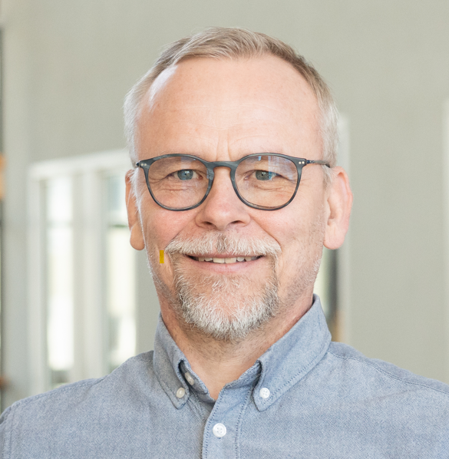

Short CV

Magnus Norgren received his PhD in physical chemistry from Lund University in 2001. He is full professor in chemical engineering and group leader for the Surface and Colloid Engineering research group at FSCN Research Centre, Mid-Sweden University, Sundsvall. Previously, Norgren was postdoctoral researcher at the Department of Fiber and Polymer Technology, KTH The Royal Institute of Technology, Stockholm, and Department of Applied Maths, Australian National University, Canberra. Norgren has three years working experience from the chemical and forest industry, he is co-founder of the spin-off company, Chemseq International AB, developing and commercializing chelating surfactants, where he also was CEO for one year.

Bibliometric data
More than 100 per-reviewed journal publications, 4 book chapters, 3 patents granted in in different countries, one of these patents commercialized by Valmet (LignoBoost™). Selected cover pages in Cellulose (2024), and Sustainability (2025). H-index 39 (Google Scholar, 260411), 35 (Scopus). Supervisor for 25 PhD students; 14 main, 11 assisting (5 were industrial PhD students).

Selection of the 10 most relevant publications and/or patents

Norgren, M.; Edlund, H.; Wågberg, L. (2002) Aggregation of lignin derivatives under alkaline conditions. Kinetics and aggregate structure. Langmuir, Vol. 18, pp. 2859-2865. https://doi.org/10.1021/la011627d
Notley, S.M; Norgren, M. (2006) Measurement of interaction forces between lignin and cellulose as a function of aqueous electrolyte solution conditions. Langmuir, Vol. 22, pp. 11199-11204. https://doi.org/10.1021/la0618566
Gärdlund, L.; Wågberg, L.; Norgren, M. (2007) New insights into the structure of polyelectrolyte complexes. J. Colloid Interface Sci., Vol 312, pp. 237-246. https://doi.org/10.1016/j.jcis.2007.03.075
Wågberg, L.; Decher, G.; Norgren, M.; Lindström, T.; Ankerfors, M.; Axnäs, K. (2008) The build-up of polyelectrolyte multilayers of microfibrillated cellulose (MFC) and cationic polyelectrolytes. Langmuir, Vol. 24, pp. 784-795. https://doi.org/10.1021/la702481v
Norgren, M.; Edlund, H. (2014) Lignin: Recent advances and emerging applications. Curr. Opin. Colloid Interface Sci., Vol. 19, pp. 409-416; https://doi.org/10.1016/j.cocis.2014.08.004
Lindman, B.; Medronho, B.; Costa, C.; Alves, L.; Edlund, H.; Norgren, M. (2017) The relevance of cellulose structural features and interactions on dissolution, regeneration, gelation and plasticization phenomena. Phys. Chem. Chem. Phys., Vol. 19, pp. 23704-23718; https://doi.org/10.1039/C7CP02409F
Costa, C.; Medronho, B.; Filipe, A.; Mira, I.; Lindman, B.; Edlund, H.; Norgren, M. (2019) Emulsion formation and stabilization by biomolecules: The leading role of cellulose. Polymers, Vol. 11, 1570; https://doi.org/10.3390/polym11101570
Zhang, R.; Dahlström, C.; Zou, H.; Jonzon, J.; Hummelgård, M.; Örtegren, J.; Blomquist, N.; Yang, Y.; Andersson, H.; Olsen, M.; Norgren, M.; Olin, H.; Wang, Z.L. (2020) Cellulose-based fully-green triboelectric nanogenerators with output power density of 300 W/m2. Adv. Mater., Vol. 32, 2002824; https://doi.org/10.1002/adma.202002824
Lindman, B.; Medronho, B.; Alves, L.; Norgren, M.; Nordenskiöld, L. (2021) Hydrophobic interactions control the self-assembly of DNA and cellulose. Quart. Rev. Biophys., Vol. 54, e3, pp. 1-22; https://doi.org/10.1017/S0033583521000019
Dahlström, C.; Eivazi, A.; Nejström, M.; Zhang, R.; Iftikhar, H.; Rojas, O.; Medronho, B.; Norgren, M. (2024) Regenerated cellulose properties tailored for optimized triboelectric output and the effect of counter-tribolayers. Cellulose, Vol. 31, pp. 2047-2061; https://doi.org/10.1007/s10570-024-05745-8

